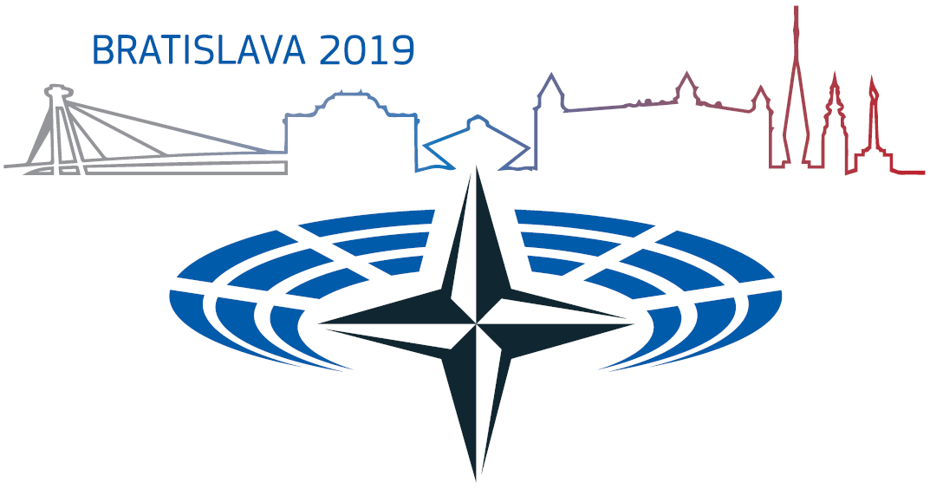

SPRING SESSION 2019 | PRESS ACCREDITATION FORM

Bratislava, Slovakia, 31 May – 3 June 2019

To apply for accreditation, please complete the registration form below. In case of any questions, feel free to contact the **Media and Public Relations Department of the Chancellery of the National Council of the Slovak Republic** at:

**Natália Michalčíková |** [**press.nato@nrsr.sk**](mailto:press.nato@nrsr.sk)

**The completed press accreditation form shall be submitted to** [**press.nato@nrsr.sk**](mailto:press.nato@nrsr.sk) **until 3 May 2019 at the latest.**

**Forms submitted after this date will not be accepted.**

|  |  |  |  |  |
| --- | --- | --- | --- | --- |
| **Media outlet** | | Name of the organisation/outlet | |  |
| Address | |  |
| Contact details | Phone |  |
| E-mail |  |
| **Personal Information** | | First name | |  |
| Last name | |  |
| Position | |  |
| Date of birth | |  |
| Permanent residence | |  |
| ID/passport number | |  |
| Contact details | Phone |  |
| E-mail |  |
| **Required attachments** | | - **digital photo** (3,5 cm x 4,5 cm, vertical photo, JPG format, 300 DPI resolution) | | - **photocopy of a valid press card** (JPG format) |
|  | **I have read and understood the note* and will submit the accreditation form and required attachments.** | | | |
|  | **I agree to the terms of the procession of my personal data:**  *“The Chancellery of the National Council of the Slovak Republic, the controller according to the General Data Protection Regulation, processes the personal data of the data subject and informs about the procession of the personal data of the data subject* [*on this website*](https://www.nrsr.sk/web/Dynamic/DocumentPreview.aspx?DocID=464676) *in line with this regulation. In case of any additional questions or claims regarding the procession of the personal data, please contact the data protection officer at* [*zodpovednaosoba@nrsr.sk*](mailto:zodpovednaosoba@nrsr.sk)*.”* | | | |

***\*Note***:

All applications are subject to review. You will be notified by the Chancellery of the National Council of the Slovak Republic when/if your request is accepted and will then receive forther organziational information on the event.

Applicants eligible for press accreditation are excusively the representatives of media outlets, including any listed print, audio-visual and online media or press agencies. The applicant is of no legal entitlement herein.

We kindly ask the media representatives to complete their applications listing the correct information. Please note that errors such as listing the last name in place of the first name or incorrect ID number may result in ineligibility for press accreditation due to the failing background checks on an applicant.