15 September 2022

Implications of the End of Temporary Correction for Estonia and Croatia’s ESM Accession for the ESM Capital Contribution Key

The temporary correction of the European Stability Mechanism (ESM) contribution key for Estonia will expire on 1 January 2023. On the same date, Croatia will become part of the euro area and eligible for ESM membership. Accordingly, Croatia applied on 29 July 2022 to join the ESM following its euro adoption, in line with Recital 7 and Article 2(1) of the ESM Treaty. These concurrent but unrelated developments have potentially far-reaching implications on ESM Members’ capital contributions, which have been already thoroughly discussed by the Task Force for Coordinated Action (TFCA). To allow for Croatia’s swift accession to the ESM and to facilitate the endorsement of an agreed way forward by the Board of Directors (BoD), to be submitted for approval to the Board of Governors (BoG), this note outlines two alternative options for updating the ESM contribution key.
Under Option 1, the BoG would be asked to approve by year-end the update of the ESM contribution key on the basis of the 2020 ECB key for all current Members and Croatia. Under this option, the BoG would also decide on a specific time for the payment of paid-in capital contributions, which would occur simultaneously for all Members six months after the entry into force of the Amending Agreement to the ESM Treaty, or at the latest by 1 January 2026.
Under Option 2, the BoG would be asked to approve the adjustment of the ESM contribution key on the basis of the 2020 ECB key for Croatia only, while keeping the capital contributions of the current Members temporarily unchanged. Moreover, the ESM Members would commit to fully update the ESM contribution key on the basis of the latest ECB capital key for all Members on the occasion of accession of a new Member, or at the latest by 1 January 2026 - the end of Latvia’s temporary correction – as provided by the Treaty.
Based on the ESM’s assessment, Option 1 is deemed superior for legal, policy, and operational reasons.
The note is organised as follows. The end of Estonia’s temporary correction is explained in Section 1. The two options for the new ESM capital contribution key, as well as Croatia’s temporary correction, are analysed and presented in Section 2. Finally, Section 3 provides an overview of the key procedural steps and provisional timeline to implement the related decisions.
The Board of Directors (BoD) is asked to agree on one of the two options presented in this note in the meeting on 22 September 2022 as a way forward to include Croatia in the ESM contribution key. Following the endorsement by the BoD of one of the options, the ESM will recirculate the relevant draft BoG resolutions to allow for completion of national procedures ahead of the BoG vote.

- End of Estonia’s temporary correction
The temporary correction of the ESM contribution key for Estonia will expire on 1 January 2023. The initial contribution key, which was enshrined in Annex I of the ESM Treaty in 2012, contained a temporary correction for four founding Members (Article 42(1) of the Treaty) – Slovenia, Malta, Slovakia, and Estonia. When joning the ESM, the temporary corrections of Latvia’s and Lithuania’s contribution keys were also applied for a period of 12 years from their respective dates of euro adoption. Similarly, a new Member may benefit from a temporary correction of its contribution key under the conditions set out in Article 42(2) of the Treaty.
Following the end of the temporary correction period for Slovenia in 2019, Malta in 2020, and Slovakia in 2021, there are now three Members still benefitting from a temporary correction of their contribution keys, with Estonia being the next to conclude the correction period on 1 January 2023. Latvia’s temporary correction will expire on 1 January 2026, and Lithuania’s on 1 January 2027.
As set out in the Treaty, when a Member’s temporary correction period ends, the contribution key for the subscription of the authorised capital stock is adjusted, authorised capital stock is transferred among Members to the extent necessary, and the ESM Board of Governors (BoG) amends the annexes of the Treaty accordingly (Article 11(3) lit. b, (5) and (6) of the Treaty).
The required adjustments in the ESM contribution key, subscribed capital and associated paid-in capital transfers due to the end of temporary correction period for Estonia are presented in Table 1. The current ESM contribution key – which derives from the 2009 ECB contribution key – is used as the basis for the adjustments due to the expiration of the temporary correction for Estonia. This is consistent with the approach taken at the end of Slovenia, Malta, and Slovakia’s correction periods. As a result, Estonia’s subscribed capital would increase by €488.7 million, including an increase of €55.85 million of paid-in capital. The subscribed and paid-in capital for those Members still benefitting from a correction (i.e., Latvia and Lithuania) are not affected by the adjustments resulting from the end of Estonia’s temporary correction.
Table 1 – Estimated values following the end of the temporary correction for Estonia

 | Previous ESM contribution key (%) | Updated ESM contribution key (%) | Updated Number of shares | Capital subscription - Updated authorised capital (EUR) | Capital subscription - Updated paid-in capital (EUR) | Updated reallocations - authorised capital (EUR) | Updated reallocations - paid-in capital (EUR)
Belgium | 3.4454 | 3.4430 | 242,662 | 24,266,200,000 | 2,773,280,000 | -17,000,000 | -1,940,000
Germany | 26.8992 | 26.8804 | 1,894,528 | 189,452,800,000 | 21,651,750,000 | -132,600,000 | -15,150,000
Estonia | 0.1847 | 0.2541 | 17,907 | 1,790,700,000 | 204,650,000 | 488,700,000 | 55,850,000
Ireland | 1.5777 | 1.5766 | 111,117 | 11,111,700,000 | 1,269,910,000 | -7,800,000 | -890,000
Greece | 2.7910 | 2.7891 | 196,573 | 19,657,300,000 | 2,246,550,000 | -13,700,000 | -1,560,000
Spain | 11.7953 | 11.7871 | 830,750 | 83,075,000,000 | 9,494,290,000 | -58,200,000 | -6,650,000
France | 20.2003 | 20.1862 | 1,422,720 | 142,272,000,000 | 16,259,660,000 | -99,600,000 | -11,380,000
Italy | 17.7506 | 17.7382 | 1,250,187 | 125,018,700,000 | 14,287,850,000 | -87,500,000 | -10,000,000
Cyprus | 0.1945 | 0.1943 | 13,696 | 1,369,600,000 | 156,530,000 | -900,000 | -100,000
Latvia | 0.2746 | 0.2746 | 19,353 | 1,935,300,000 | 221,200,000 | 0 | 0
Lithuania | 0.4063 | 0.4063 | 28,634 | 2,863,400,000 | 327,200,000 | 0 | 0
Luxembourg | 0.2482 | 0.2480 | 17,477 | 1,747,700,000 | 199,740,000 | -1,300,000 | -150,000
Malta | 0.0898 | 0.0897 | 6,323 | 632,300,000 | 72,260,000 | -400,000 | -50,000
Netherlands | 5.6650 | 5.6610 | 398,988 | 39,898,800,000 | 4,559,860,000 | -27,900,000 | -3,190,000
Austria | 2.7581 | 2.7561 | 194,252 | 19,425,200,000 | 2,220,020,000 | -13,600,000 | -1,560,000
Portugal | 2.4863 | 2.4846 | 175,114 | 17,511,400,000 | 2,001,300,000 | -12,200,000 | -1,400,000
Slovenia | 0.4670 | 0.4667 | 32,894 | 3,289,400,000 | 375,930,000 | -2,300,000 | -260,000
Slovakia | 0.9849 | 0.9842 | 69,369 | 6,936,900,000 | 792,790,000 | -4,900,000 | -560,000
Finland | 1.7811 | 1.7798 | 125,443 | 12,544,300,000 | 1,433,630,000 | -8,800,000 | -1,010,000
Source: ESM staff calculations.

- Croatia’s accession to the ESM
Following the approval by the ECOFIN Council in July 2022, Croatia will adopt the euro on 1 January 2023. In this context, and in line with the established accession practice, Croatia applied on 29 July 2022 to become the ESM’s 20th Member.
2.a. Option 1: Croatia’s accession on the back of the updated capital contribution key for all Members
In line with Article 10(3) of the Treaty, the accession of Croatia will entail an increase of the authorised capital stock and, accordingly, the paid-in capital. Furthermore, according to Article 11(3) of the Treaty, the contribution key for the subscription of the authorised capital stock would have to be adjusted.

Under this option, the ESM would update its contribution key based on the latest, 2020 ECB capital subscription key. In the case of the accession of Latvia and Lithuania, the 2009 ECB key was used as a basis since both countries had been EU Member States since 2004 and therefore fully accounted for in the 2009 ECB key. Article 11 of the Treaty prescribes that the ESM contribution key shall be based on the ECB key. Given that Croatia became an EU Member State in 2013, the 2009 ECB key does not account for Croatia. The Board of Governors (BoG) may take into account possible updates to the ECB's capital subscription key when the contribution key is adjusted in case a new Member accedes or when a temporary correction comes to an end (Article 11, paragraphs 4 and 3 of the ESM Treaty). Therefore, the accession of Croatia allows for updating the key.

The update of the ESM contribution key for all Members on the basis of the latest ECB key would imply the redistribution of capital shares as summarised in Table 2 below. This updated ESM key would apply to Croatia’s accession and going forward in the case of any other EU Member State becoming part of the euro area in the short- to medium-term.

In conjunction with the ESM contribution key update, under Option 1, the BoG would agree on a specific date on which the current Members would settle the payments required for the reallocation of the paid-in capital shares. It is proposed that Members who need to increase their paid-in capital contribution following the update of the ESM key – as presented in Table 2 – commit to transfer to the ESM their respective amounts simultaneously on the same date six months after the entry into force of the Amending Agreement to the ESM Treaty, or at the latest by 1 January 2026. At the same time, the ESM would transfer the amounts to those Members whose capital contribution decreases.
Table 2 – Estimated authorised and paid-in capital, and net reallocations following the end of Estonia’s temporary correction and the update of the ESM contribution key under Option 1

 | Capital subscription: authorised capital (EUR) following the end of Estonia’s temporary correction and based on current key | Capital subscription: paid-in capital (EUR) following the end of Estonia’s temporary correction and based on current key | Updated capital subscription: authorised capital (EUR) based on updated key (without Croatia) | Updated capital subscription: paid-in capital (EUR) based on updated key (without Croatia) | Net reallocations: authorised capital (EUR) due to the update of ESM key | Net reallocations: paid-in capital (EUR) due to the update of ESM key
Belgium | 24,266,200,000 | 2,773,280,000 | 25,761,200,000 | 2,944,140,000 | 1,495,000,000 | 170,860,000
Germany | 189,452,800,000 | 21,651,750,000 | 186,400,800,000 | 21,302,940,000 | -3,052,000,000 | -348,810,000
Estonia | 1,790,700,000 | 204,650,000 | 1,991,900,000 | 227,650,000 | 201,200,000 | 23,000,000
Ireland | 11,111,700,000 | 1,269,910,000 | 11,973,800,000 | 1,368,430,000 | 862,100,000 | 98,520,000
Greece | 19,657,300,000 | 2,246,550,000 | 17,490,400,000 | 1,998,900,000 | -2,166,900,000 | -247,650,000
Spain | 83,075,000,000 | 9,494,290,000 | 84,318,300,000 | 9,636,370,000 | 1,243,300,000 | 142,080,000
France | 142,272,000,000 | 16,259,660,000 | 144,419,400,000 | 16,505,070,000 | 2,147,400,000 | 245,410,000
Croatia | - | - | - | -
Italy | 125,018,700,000 | 14,287,850,000 | 120,124,900,000 | 13,728,560,000 | -4,893,800,000 | -559,290,000
Cyprus | 1,369,600,000 | 156,530,000 | 1,521,500,000 | 173,890,000 | 151,900,000 | 17,360,000
Latvia | 1,935,300,000 | 221,200,000 | 1,852,300,000 | 211,700,000 | -83,000,000 | -9,500,000
Lithuania | 2,863,400,000 | 327,200,000 | 2,698,000,000 | 308,340,000 | -165,400,000 | -18,860,000
Luxembourg | 1,747,700,000 | 199,740,000 | 2,329,200,000 | 266,190,000 | 581,500,000 | 66,450,000
Malta | 632,300,000 | 72,260,000 | 741,600,000 | 84,750,000 | 109,300,000 | 12,490,000
Netherlands | 39,898,800,000 | 4,559,860,000 | 41,438,800,000 | 4,735,860,000 | 1,540,000,000 | 176,000,000
Austria | 19,425,200,000 | 2,220,020,000 | 20,695,900,000 | 2,365,250,000 | 1,270,700,000 | 145,230,000
Portugal | 17,511,400,000 | 2,001,300,000 | 16,549,600,000 | 1,891,380,000 | -961,800,000 | -109,920,000
Slovenia | 3,289,400,000 | 375,930,000 | 3,404,800,000 | 389,120,000 | 115,400,000 | 13,190,000
Slovakia | 6,936,900,000 | 792,790,000 | 8,097,900,000 | 925,470,000 | 1,161,000,000 | 132,680,000
Finland | 12,544,300,000 | 1,433,630,000 | 12,988,400,000 | 1,484,390,000 | 444,100,000 | 50,760,000
Total | 704,798,700,000 | 80,548,400,000 | 704,798,700,000 | 80,548,400,000 | - | -
Source: ESM staff calculations.

Annex 1 presents the percentage change in the ESM contribution key for each Member due to the key update. Table 3 presents the updated ESM contribution key before and after Croatia’s accession under Option 1.
Table 3 – Estimated ESM subscription key before and after Croatia’s accession under Option 1

 | Updated ESM key before Croatia’s accession | Updated ESM key following Croatia’s accession | Updated capital subscription: authorised capital (EUR) following Croatia’s accession | Updated capital subscription: paid-in capital (EUR) following Croatia’s accession
Belgium | 3.6551 | 3.6362 | 25,761,200,000 | 2,944,140,000
Germany | 26.4474 | 26.3105 | 186,400,800,000 | 21,302,940,000
Estonia | 0.2826 | 0.2812 | 1,991,900,000 | 227,650,000
Ireland | 1.6989 | 1.6901 | 11,973,800,000 | 1,368,430,000
Greece | 2.4816 | 2.4688 | 17,490,400,000 | 1,998,900,000
Spain | 11.9635 | 11.9015 | 84,318,300,000 | 9,636,370,000
France | 20.4909 | 20.3848 | 144,419,400,000 | 16,505,070,000
Croatia | 0.0000 | 0.5176 | 3,666,700,000 | 419,050,000
Italy | 17.0439 | 16.9556 | 120,124,900,000 | 13,728,560,000
Cyprus | 0.2159 | 0.2148 | 1,521,500,000 | 173,890,000
Latvia | 0.2628 | 0.2615 | 1,852,300,000 | 211,700,000
Lithuania | 0.3828 | 0.3808 | 2,698,000,000 | 308,340,000
Luxembourg | 0.3305 | 0.3288 | 2,329,200,000 | 266,190,000
Malta | 0.1052 | 0.1047 | 741,600,000 | 84,750,000
Netherlands | 5.8795 | 5.8491 | 41,438,800,000 | 4,735,860,000
Austria | 2.9364 | 2.9212 | 20,695,900,000 | 2,365,250,000
Portugal | 2.3481 | 2.3360 | 16,549,600,000 | 1,891,380,000
Slovenia | 0.4831 | 0.4806 | 3,404,800,000 | 389,120,000
Slovakia | 1.1490 | 1.1430 | 8,097,900,000 | 925,470,000
Finland | 1.8429 | 1.8333 | 12,988,400,000 | 1,484,390,000
Total | 100 | 100 | 708,465,400,000 | 80,967,450,000
Source: ESM staff calculations.

2.b. Option 2: Croatia’s accession on the back of the updated capital contribution key for Croatia only
Under this option, based on the proposal made by France during the TFCA consultations, the BoG would decide on the basis of Article 11(4) of the ESM Treaty to take into account the 2020 ECB key for Croatia only. As in Option 1, Croatia’s capital contribution would come on top of the existing capital stock. However, the capital contributions of the current Members would be left temporarily unchanged. Therefore, this option would not entail an immediate redistribution of capital contributions among the current Members. Table 4 presents the updated ESM contribution key following Croatia’s accession under Option 2.
Table 4 – Estimated ESM subscription key before and after Croatia’s accession under Option 2
 | ESM key following the end of Estonia’s temporary correction¹ | ESM key following Croatia’s accession | Capital subscription: authorised capital (EUR) following Croatia’s accession | Capital subscription: paid-in capital (EUR) following Croatia’s accession
Belgium | 3.4430 | 3.4252 | 24,266,200,000 | 2,773,280,000
Germany | 26.8804 | 26.7413 | 189,452,800,000 | 21,651,750,000
Estonia | 0.2541 | 0.2528 | 1,790,700,000 | 204,650,000
Ireland | 1.5766 | 1.5684 | 11,111,700,000 | 1,269,910,000
Greece | 2.7891 | 2.7746 | 19,657,300,000 | 2,246,550,000
Spain | 11.7871 | 11.7260 | 83,075,000,000 | 9,494,290,000
France | 20.1862 | 20.0817 | 142,272,000,000 | 16,259,660,000
Croatia | - | 0.5176 | 3,666,700,000 | 419,050,000
Italy | 17.7382 | 17.6464 | 125,018,700,000 | 14,287,850,000
Cyprus | 0.1943 | 0.1933 | 1,369,600,000 | 156,530,000
Latvia | 0.2746 | 0.2732 | 1,935,300,000 | 221,200,000
Lithuania | 0.4063 | 0.4042 | 2,863,400,000 | 327,200,000
Luxembourg | 0.2480 | 0.2467 | 1,747,700,000 | 199,740,000
Malta | 0.0897 | 0.0892 | 632,300,000 | 72,260,000
Netherlands | 5.6610 | 5.6317 | 39,898,800,000 | 4,559,860,000
Austria | 2.7561 | 2.7419 | 19,425,200,000 | 2,220,020,000
Portugal | 2.4846 | 2.4717 | 17,511,400,000 | 2,001,300,000
Slovenia | 0.4667 | 0.4643 | 3,289,400,000 | 375,930,000
Slovakia | 0.9842 | 0.9791 | 6,936,900,000 | 792,790,000
Finland | 1.7798 | 1.7706 | 12,544,300,000 | 1,433,630,000
Total | 100 | 100 | 708,465,400,000 | 80,967,450,000
Source: ESM staff calculations.
Note 1: The current key (based on the 2009 ECB key) after the end of temporary correction for Estonia.

2.c. ESM’s assessment of the two options
From the ESM point of view, Option 1 is preferable for legal, policy, and operational reasons. For legal reasons, while usually optional for the BoG under Article 11(4) of the Treaty, the fact that the ESM key “shall” be based on the ECB key (Article 11(1) of the Treaty), in conjunction with the fact that Croatia is not included in the 2009 ECB key, which is the basis of the current ESM key, necessitates an update of the ESM capital key. Subsequently, Article 29 of the ESCB Statute provides that the key for subscription of the ECB’s capital shall be adjusted every five years. This was done most recently through Decision (EU) 2019/43 (ECB/2018/27), which was repealed in 2020 (following Brexit) by Decision (EU) 2019/43 (ECB/2020/3), which provides for the ECB key currently in force. As previous decisions on ECB keys were repealed, they no longer exist. This also fits better with the purpose of Article 11(5) of the Treaty to reflect economic and demographic developments of the Members in the ESM key from time to time.

From a policy perspective, the update of the key for all Members would ensure an even-handed treatment and would avoid creating precedents for future accessions, which could not be ruled out under Option 2, unless a clear commitment to update the ESM key at the next possible occasion is made now. Specifically, under Option 2, an update of the ESM contribution key for all Members would be approved by the BoG on the occasion of accession of the next ESM Member or at the latest by 1 January 2026, which is the end of Latvia’s temporary correction (in line with Article 11(4) of the ESM Treaty).

2.d. Temporary correction of Croatia’s capital contribution key
In line with Article 42 of the Treaty, Croatia can benefit from a temporary correction of the capital contribution key for a period of 12 years after the date of its euro adoption. This means that following the adoption of the euro on 1 January 2023, Croatia will benefit from a temporary correction expiring on 1 January 2035. During this period, Croatia’s initial capital subscription to the ESM will be lower, thus leading to a temporarily lower paid-in capital contribution. Once this period comes to an end, Croatia will subscribe additional shares and deposit the amount corresponding to the additional paid-in shares.
This implies that in 2023, upon Croatia acceding to the ESM, the authorised capital stock of the ESM shall be increased by the amount calculated according to Article 42(2) of the Treaty and initially subscribed by Croatia. As presented in Table 5 below, this corrected amount of Croatia’s authorised capital contribution is €3.6667 billion. Following the expiration of the temporary correction for Croatia on 1 January 2035, the authorised capital stock will be further increased by €2.0672 billion, which presents the difference between Croatia’s contribution calculated without taking into account the temporary correction (the “non-corrected amount”) and the corrected amount. Croatia will then subscribe to the corresponding shares and make its payment contribution for the paid-in shares.
Table 5 – Estimated values for Croatia’s share in the ESM capital and contributions to the ESM’s subscribed and paid-in capital during and after the temporary correction period

 | Croatia’s share in ESM capital | Croatia’s subscribed capital | Croatia’s paid-in capital
2023 (corrected amount during temporary correction period) | 0.5176% | € 3.6667 billion | € 419.05 million (paid in 5 annual instalments)
2035 (additional contribution after end of temporary correction) |  | € 2.0672billion | € 236.25 million
Non-corrected amounts in 2035 | 0.8044%¹ | € 5.7339 billion | € 655.3 million
Source: ESM staff calculations.
Note 1: This reflects Croatia’s contribution key in 2035 in case no new Members join.

Regardless which of the two options presented above is chosen, Croatia’s accession will increase the total ESM subscribed capital from €704.7987 billion to €708.4654 billion in 2023 due to the addition of the corrected contribution of Croatia equal to €3.6667 billion.

- Procedural steps for the end of Estonia’s temporary correction and the accession of Croatia
This section provides an overview of the procedural steps that need to be followed before the end of 2022 to implement the adjustments related to the end of Estonia’s temporary correction and Croatia’s accession. Decisions are subject to national procedures. The provisional timeline summarising key decision-making steps under both options is provided in Annex 2.
3.a. Adjustments related to the end of Estonia’s temporary correction
In line with Article 3(10) of the ESM By-Laws, the BoD is asked to consider and endorse the proposed changes to the contribution key due to the end of the temporary correction of Estonia on 22 September 2022. Upon this endorsement, the ESM would submit the proposal to the BoG for approval no later than in early December 2022, depending on national procedures.
The practical implementation of the BoG decision would follow the same procedure as in the previous cases: the ESM would receive from Estonia the amount corresponding to its additional subscription of paid-in shares. The ESM would then transfer the respective amounts to the ESM Members whose shares are to be transferred to Estonia, and would thereupon notify the Depositary of the entry into force of the amendments made to the Annexes I and II to the ESM Treaty. The amended Annexes I and II of the ESM Treaty would enter into force on 1 January 2023 or on the date of completion of the transfers (whichever is the latest).
3.b. Update of the contribution key
Concurrently with the decisions related to the end of Estonia’s temporary correction, the BoD is asked to endorse one of the two options presented in this note regarding the update of the contribution key in the context of Croatia’s accession. Upon the BoD endorsement, the ESM would submit the proposal to the BoG for approval by early December 2022, depending on national procedures.
Under either of the two options, the adjustment to the ESM key will take effect on the effective date of Croatia’s accession. Croatia’s contribution to the authorised and paid-in capital will be added to the paid-in capital. The overall adjustments to the contribution key and the subscriptions of the authorised capital stock will be presented in the amended Annexes I and II of the Treaty for BoG approval. In accordance with the Treaty, Croatia’s initial capital will be paid in five annual instalments, of which the first one shall be paid within fifteen days of the accession.
3.c. Decisions related to Croatia’s accession
As for Croatia’s accession, the Board of Governors (BoG) will be asked, as part of the same package of decisions required to update the contribution key, to consider the following resolutions:
- Approval of the application for accession of Croatia and the detailed technical terms; and
- Approval of the adaptations to be made to the Treaty as a direct consequence of the accession of Croatia
The detailed technical terms determine the terms of accession of Croatia to the ESM and address important issues such as Croatia’s contribution to the ESM key and subscription to the authorised capital stock (including the application of a temporary correction), the deposit of the instrument of accession, the entry into force of the Treaty for Croatia, the binding nature of existing ESM resolutions and decisions for Croatia and its payment of the paid-in capital. The accession of Croatia is subject to Croatia’s adherence to the detailed technical terms to which Croatia shall refer to in its instrument of accession.
The adaptations to be made to the Treaty as a direct consequence of the Croatia’s accession cover the increase in the authorised capital stock and, correspondingly, the number of shares and the paid-in capital, the authentic languages of the Treaty, the contribution key (Annex I) and the subscriptions to the authorised capital stock (Annex II). To facilitate national procedures, these amendments are translated into the 17 authentic languages of the Treaty and Croatian by the Council Secretariat which acts as the Depositary. The Managing Director shall notify the Depositary of the adaptations to the Treaty approved by the Board of Governors as a direct consequence of Croatia’s accession.
Following the adoption of the above-mentioned resolutions, Croatia shall adopt the Treaty ratification law. Provided that the amended Treaty is in force before Croatia’s accession, Croatia’s law would concern only the amended Treaty. In case of further delays in the ratification of the amended Treaty, Croatia would need to request accession to and to ratify the Amending Agreement in parallel with its accession to the current Treaty; the simultaneous deposit of instruments of accession to both the ESM Treaty and its Amendment Agreement would be required for the approval of the application to the ESM to take effect.
This ratification law shall reflect the detailed technical terms agreed for Croatia’s accession. The Croatian text of the Treaty shall be equally authentic upon accession. A draft version will be prepared by the Depositary and circulated to ESM Members and Croatia in due time. The Depositary will then finalise the text and circulate the final version to the Members upon entry into force. Croatia shall deposit its instrument of accession with the Depositary together with an act confirming that it shares the interpretation outlined in the 27 September 2012 interpretative declaration on the ESM. The Depositary shall notify the other Contracting Parties of the deposit and the date thereof.
Pursuant to Article 48(3) of the Treaty, the Treaty shall enter into force for Croatia on the twentieth day following the deposit of its instrument of accession. Pursuant to the resolution approving the amendments to be made to the Treaty as a direct consequence of Croatia’s accession, said amendments shall also enter into force for all Members on the twentieth day following the deposit of Croatia’s instrument of accession. The Depositary shall establish a consolidated version of all the different authentic texts and send them to the ESM and its Members.

Annex 1: Percentage change in the ESM contribution key due to the key update under Option 1

 | Current ESM Contribution Key (%) | Updated ESM Contribution Key (%) | Change in the ESM Contribution Key due to the update (%)
Belgium | 3.4430 | 3.6551 | 6.1607
Germany | 26.8804 | 26.4474 | -1.6109
Estonia¹ | 0.2541 | 0.2826 | 11.2238
Ireland | 1.5766 | 1.6989 | 7.7570
Greece | 2.7891 | 2.4816 | -11.0245
Spain | 11.7871 | 11.9635 | 1.4962
France | 20.1862 | 20.4909 | 1.5093
Croatia | - | - | -
Italy | 17.7382 | 17.0439 | -3.9144
Cyprus | 0.1943 | 0.2159 | 11.1051
Latvia | 0.2746 | 0.2628 | -4.2926
Lithuania | 0.4063 | 0.3828 | -5.7828
Luxembourg | 0.2480 | 0.3305 | 33.2570
Malta | 0.0897 | 0.1052 | 17.3038
Netherlands | 5.6610 | 5.8795 | 3.8601
Austria | 2.7561 | 2.9364 | 6.5428
Portugal | 2.4846 | 2.3481 | -5.4926
Slovenia | 0.4667 | 0.4831 | 3.5115
Slovakia | 0.9842 | 1.1490 | 16.7411
Finland | 1.7798 | 1.8429 | 3.5427
Total | 100 | 100 | -
Source: ESM staff calculations.
Note 1: The key for Estonia reflect its full capital contribution (after the end of its temporary correction period).

Annex 2: Expected timeline for Croatia’s accession and adjustments to the ESM contribution key under Option 1 and Option 2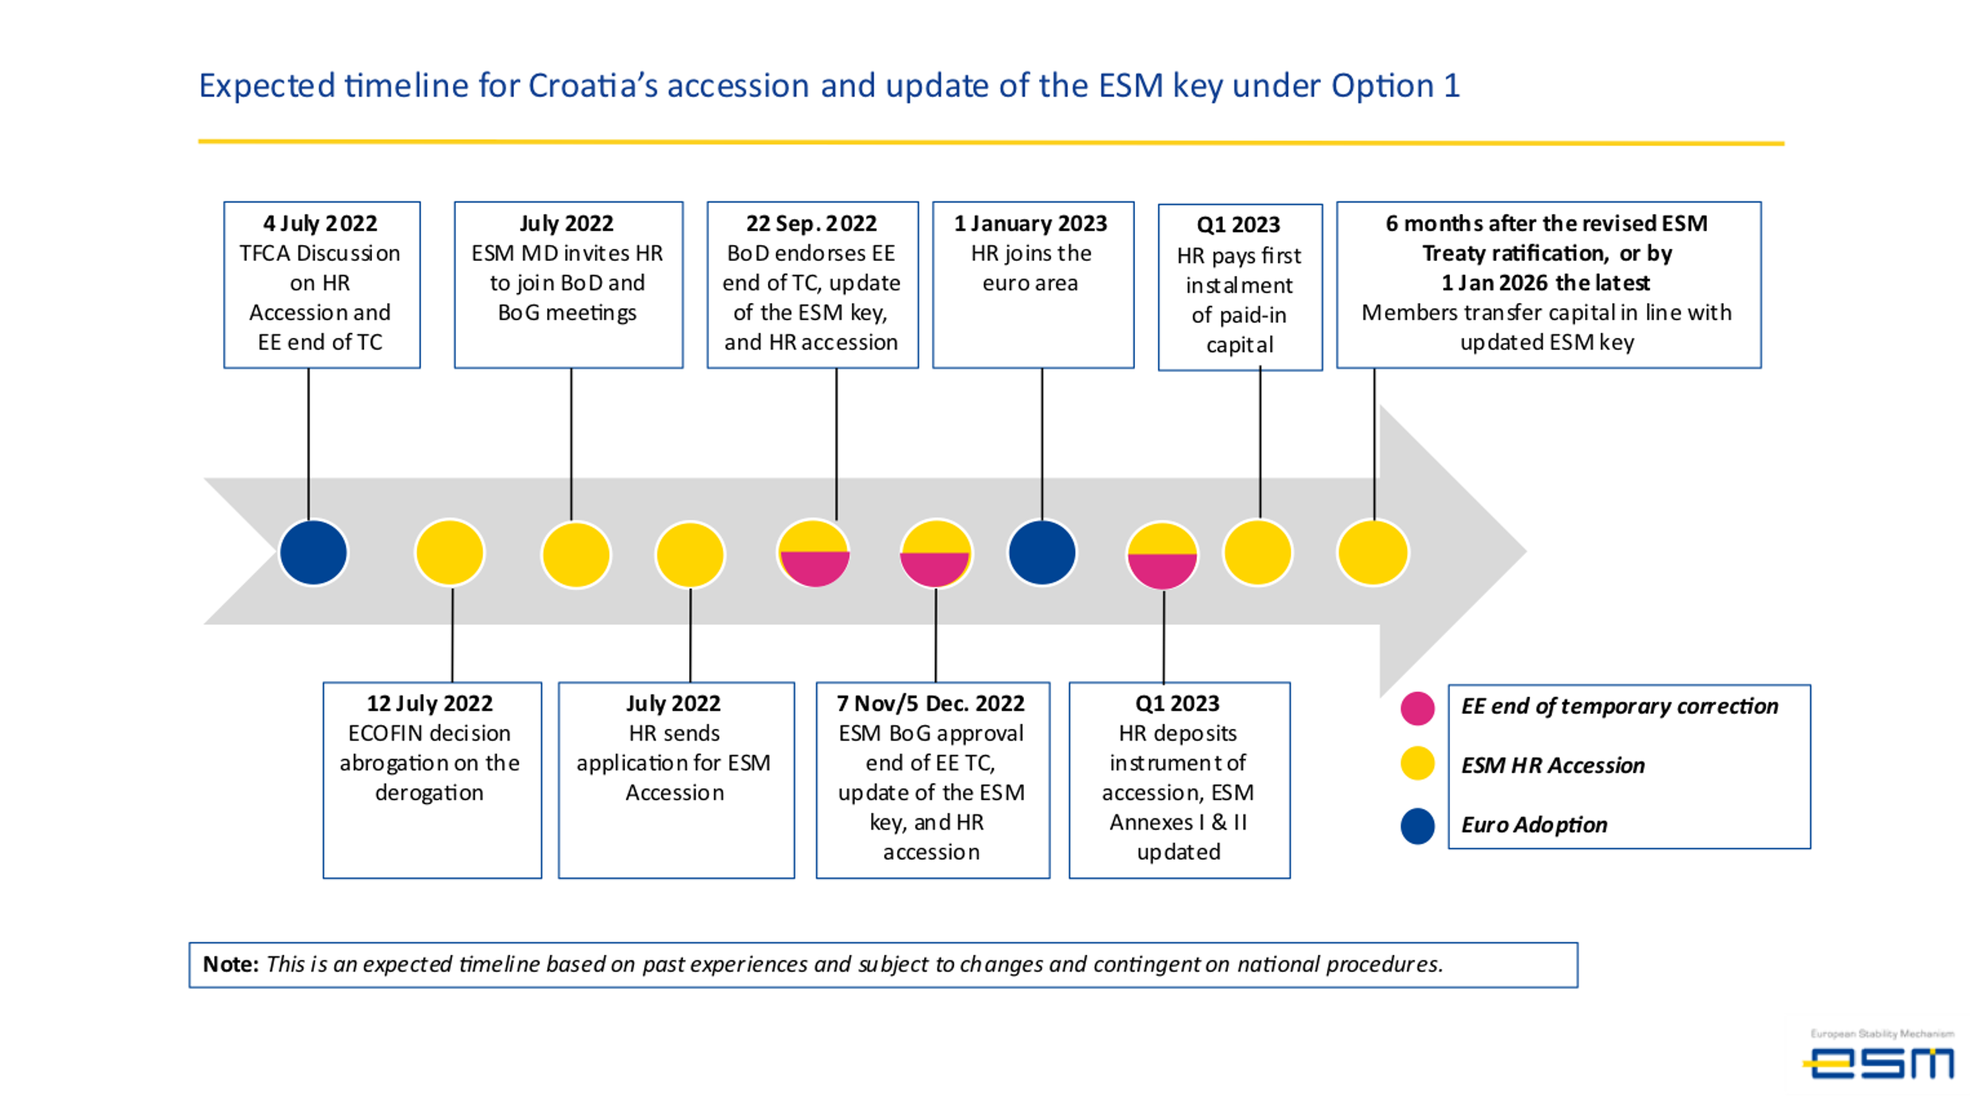

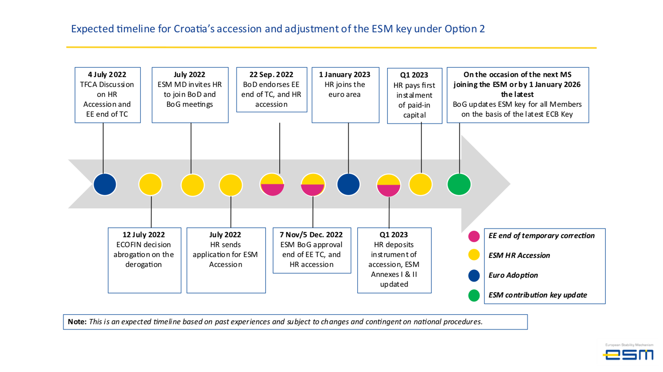

Unlike for the founding Members benefitting from a temporary correction, a temporary correction for acceding Members does not entail the temporary subscription of additional shares for the existing Members.
Article 42(2) of the ESM Treaty states that if a new ESM Member’s GDP per capita at market prices in euro in the year immediately preceding its accession to the ESM is less than 75 % of the EU average GDP per capita at market prices, then the new Member can benefit from a temporary correction.
The ECB key is for each Member State based on the two determinants of equal weight: the country’s share in the total population and GDP of the EU. The differences between the 2020 and 2009 ECB key are due to the changes in relative sizes of the countries’ population and GDP.
This period, to be decided by the BoG by mutual agreement, would allow ESM Members to appropriate the funds necessary for this payment in their internal procedures.
As in the case of transactions required to implement an end of a Member’s temporary correction period, the ESM will send detailed instructions for settling the transactions to reallocate paid-in capital shares, including the precise date, in line with the BoG decision, in order to execute all receiving and paying out transactions ideally on the same date.
In line with past practice for LV and LT, when the temporary correction for HR ends, the authorised capital stock will be increased by an amount being the difference between the Republic of Croatia’s contribution calculated without taking into account the temporary correction and the amount initially subscribed by the Republic of Croatia (see also Table 5).
A temporary correction is calculated in line with Article 42(2) of the Treaty and is equal to the sum of 25% of the percentage share in the ECB capital of the national central bank of that Member, determined in accordance with Article 29 of the ESCB Statute, and 75% of that Member's percentage share in the gross national income (GNI) at market prices in euro of the euro area in the year immediately preceding its accession to the ESM. The same article also specified that these percentages shall be rounded up or down to the nearest multiple of 0,0001 percentage points and that the statistical terms shall be those published by Eurostat.
When calculating Croatia’s temporary correction, the Eurostat GNI figures used were those available on 23 May 2022, which were provisional quarterly figures. Given that final Eurostat yearly data for Croatia’s 2021 GNI were not yet available, these figures are subject to possible revisions pending the publication of the final annual 2021 GNI figures.
These amounts can be subject to change even during the period in which the temporary correction applies in case there is a change in the authorised capital stock or in the distribution between the subscribed capital and the paid-in capital. The precise amounts of the corrected and uncorrected contributions by Latvia and Lithuania are specified in the detailed technical terms related to their accession approved by the Board of Governors on 23 October 2013 and 13 October 2014 respectively. The initial “discount” applied to Latvia and Lithuania’s contribution (i.e., the difference between their non-corrected and corrected authorised capital amounts calculated at the time of their accession) was kept constant in the calculations for Croatia’s accession, while the actual amounts changed as the result of rebasing of the ESM key under Option 1 in the context of the authorised capital increase due to Croatia’s accession.
The date of accession is formally the day when the ESM Treaty enters into force for the new ESM Member. According to the ESM Treaty, this is on the twentieth day following the deposit of its instrument of accession with the General Secretariat of the Council of the European Union.

